# **Name: Abdurrahman Qureshi**

# **Roll No: 210451**

Practical No: 1

**1) Write a program to print “Welcome to PHP”**

**CODE:**

<!doctype html>  
<html lang="en">  
<head>  
 <meta charset="UTF-8">  
 <meta name="viewport"  
 content="width=device-width, user-scalable=no, initial-scale=1.0, maximum-scale=1.0, minimum-scale=1.0">  
 <meta http-equiv="X-UA-Compatible" content="ie=edge">  
 <title>Document</title>  
 <?php  
 echo "qarq90 welcomes you to PHP"  
 ?>  
</head>  
<body>  
  
</body>  
</html>

**OUTPUT:**

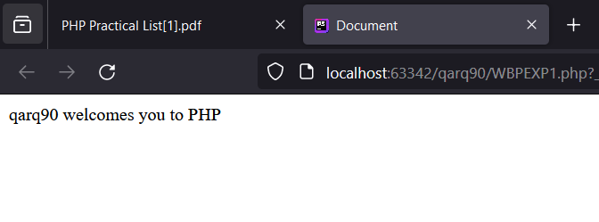

**2) Write a program to demonstrate the use of STATIC keyword in PHP**

**CODE:**

<!doctype html>  
<html lang="en">  
<head>  
 <meta charset="UTF-8">  
 <meta name="viewport"  
 content="width=device-width, user-scalable=no, initial-scale=1.0, maximum-scale=1.0, minimum-scale=1.0">  
 <meta http-equiv="X-UA-Compatible" content="ie=edge">  
 <title>Document</title>  
 <?php  
 function playingWithStaticVariables(): int  
 {  
 static $numR = 10;  
 $numR++;  
 return $numR;  
 }  
 echo "numR Value: " . playingWithStaticVariables() . "<br>";  
 echo "numR Value: " . playingWithStaticVariables() . "<br>";  
 echo "numR Value: " . playingWithStaticVariables() . "<br>";  
 ?>  
</head>  
<body>  
  
</body>  
</html>

**OUTPUT:**

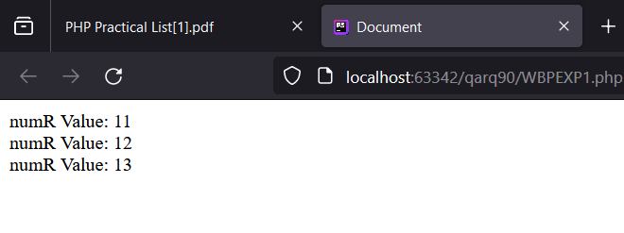

**3) Write a simple PHP program using expressions and operators. Write a Program to take three variables and perform Addition, Subtraction, Multiplication, Division and Modulus.**

**CODE:**

<!doctype html>  
<html lang="en">  
<head>  
 <meta charset="UTF-8">  
 <meta name="viewport"  
 content="width=device-width, user-scalable=no, initial-scale=1.0, maximum-scale=1.0, minimum-scale=1.0">  
 <meta http-equiv="X-UA-Compatible" content="ie=edge">  
 <title>Document</title>  
 <?php  
 $numA = 15;  
 $numB = 3;  
 $numC = $numA + $numB;  
 echo "Addition of " . $numA . " is " . $numB . " = " . $numC . "<br>";  
 $numC = $numA * $numB;  
 echo "Product of " . $numA . " is " . $numB . " = " . $numC . "<br>";  
 $numC = $numA - $numB;  
 echo "Subtraction of " . $numA . " is " . $numB . " = " . $numC . "<br>";  
 $numC = $numA / $numB;  
 echo "Division of " . $numA . " is " . $numB . " = " . $numC . "<br>";  
 ?>  
</head>  
<body>  
  
</body>  
</html>

**OUTPUT:**

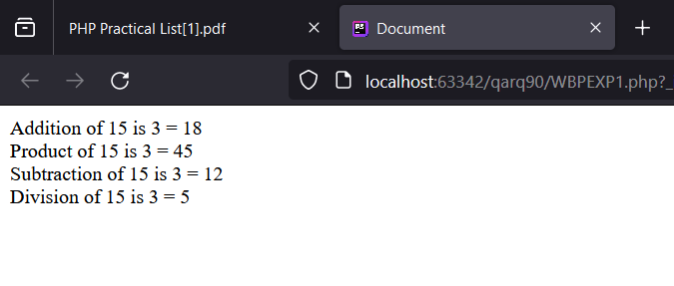

**4) Write a program to demonstrate the use of GLOBAL keyword in PHP.**

**CODE:**

<!doctype html>  
<html lang="en">  
<head>  
 <meta charset="UTF-8">  
 <meta name="viewport"  
 content="width=device-width, user-scalable=no, initial-scale=1.0, maximum-scale=1.0, minimum-scale=1.0">  
 <meta http-equiv="X-UA-Compatible" content="ie=edge">  
 <title>Document</title>  
 <?php  
 $numX = 10;  
 function playingWithGlobalVariables(): void  
 {  
 global $numX;  
 echo "The Global variable is now inside the function..." . "<br>";  
 $numX = 20;  
 }  
 echo "Before calling the function, value of global variable was " . $numX . "<br>";  
 playingWithGlobalVariables();  
 echo "After calling the function, value of global variable is " . $numX . "<br>";  
 ?>  
</head>  
<body>  
  
</body>  
</html>

**OUTPUT:**

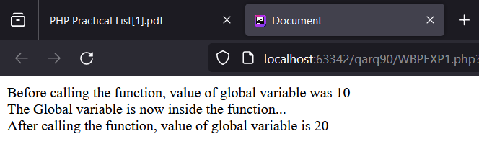

**5) Write a program to demonstrate the use of GLOBAL array in PHP.**

**CODE:**

<!doctype html>  
<html lang="en">  
<head>  
 <meta charset="UTF-8">  
 <meta name="viewport"  
 content="width=device-width, user-scalable=no, initial-scale=1.0, maximum-scale=1.0, minimum-scale=1.0">  
 <meta http-equiv="X-UA-Compatible" content="ie=edge">  
 <title>Document</title>  
 <?php  
 $numX = 10;  
 $numY = 35;  
 $numZ = 50;  
 function playingWithGlobalVariables(): void  
 {  
 echo "The Globals Arrays is now printing the values from within the function:" . "<br><br>";  
 echo "GLOBALS_ARRAY[0] : " . $GLOBALS["numX"] . "<br>";  
 echo "GLOBALS_ARRAY[1] : " . $GLOBALS["numY"] . "<br>";  
 echo "GLOBALS_ARRAY[2] : " . $GLOBALS["numZ"] . "<br>";  
 }  
 playingWithGlobalVariables();  
 ?>  
</head>  
<body>  
  
</body>  
</html>

**OUTPUT:**

